Canterbury Bankstown Council

PROPOSED DOUBLE BRICK VENEER DWELLING

IN RESPECT OF
Lot 11, 323 Marion Street YAGOONA 2199
DP: 229452

FOR
Mr Anh Duy Le & Mrs. Hoang Thuy Tien Ha
C/O WISDOM HOMES

STATEMENT OF ENVIRONMENTAL EFFECTS



17-19 Central Hills Drive Gregory Hills NSW 2557
Phone: 1300 855 775 Fax: 02 4647 1233

INTRODUCTION
This document comprises a Statement of Environmental Effects to accompany a Development Application to undertake the construction of a double story brick veneer dwelling.

SITE & SURROUNDING LOCALITY

The subject site is bounded by a frontage to Marion Street of 15.279 metres, a Western boundary of 36.485 metres, and a Eastern boundary of 36.785 metres and an Southern (rear) boundary of 15.285 metres comprising a total area of 556.4m².

The locality is a newly developed residential site which will be maintained for the proposed development.

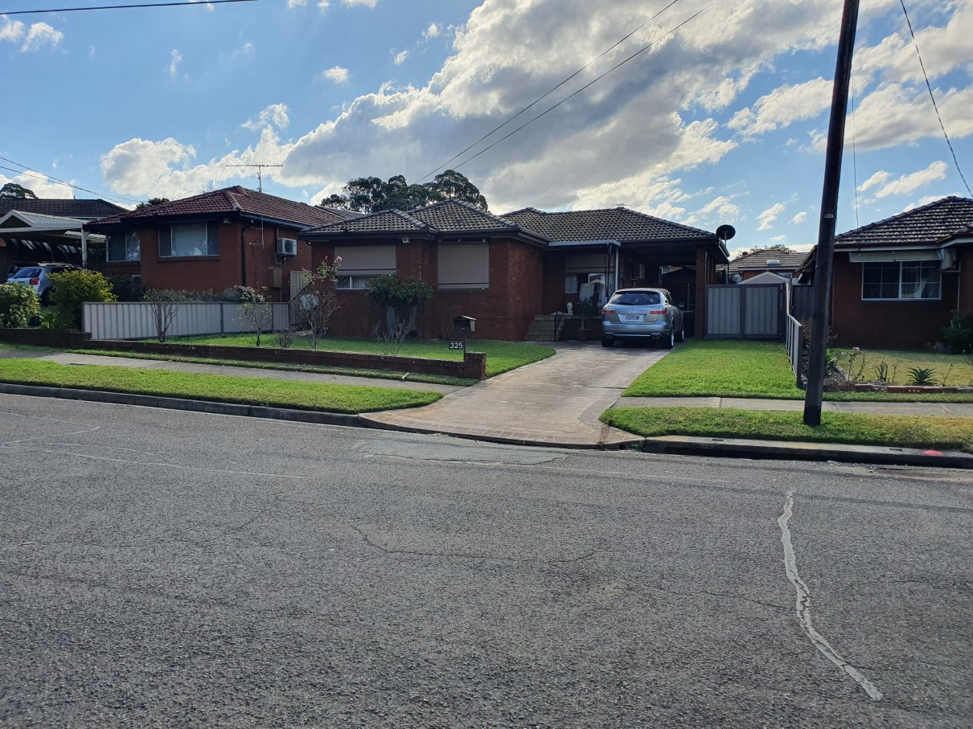

DESIGN GUIDELINES (DCP)
The proposal is for a double storey brick veneer dwelling with selected Colourbond roof. The proposed residence will have a front setback of 8.4 metres, and a rear setback of 7.8 metres. The side setbacks of the proposed development will be a minimum of 1.5m to the East side and 1.3m to the West side of the property.

The proposed dwelling will consist of:
- Garage
- 4 Bedrooms (inclusive of Master Suite with Ensuite)
- Kitchen
- Leisure Area
- Dining Area
- Main Bathroom
- Laundry
- Powder Room
- Outdoor Leisure
- Guest bedroom
- Lounge

The floor area for the main dwelling is:
- Ground Floor = 152.27m²
- First Floor Living = 141.07m²
- Porch = 2.31m²
- Garage = 39.23m²
- Outdoor Leisure = 20.89m²

The total floor area for the proposed dwelling, including Garage, Porch & Outdoor Leisure = 363.3m².

The proposed residence will be a Wisdom Homes Aspiration 36 – a design which will be adapted to the future surroundings and character in the Box Hill area.

The home is designed with style and character through the use of articulation to the external walls as well as variations to the roof, with the design minimizing the bulk and scale of our proposed development.

The overall appearance of our proposal is in keeping with Canterbury Bankstown Council DCP - Objectives and Development Control.

IMPACTS OF THE DEVELOPMENT
The proposal has no social or economic impact to the locality. Given the quality of the design the dwelling and proposed landscaping will have minimal impact on the existing streetscape other than to enhance the vision of the community.

The slab on ground construction will result in minimal disturbance to the natural slope of the subject land. Stormwater will be conveyed to the proposed rainwater tank located to the Eastern side of the proposed dwelling with the overflow discharged to the street, in which satisfies Council’s requirements.

COMPLIANCE WITH DEVELOPMENT STANDARDS
The premises is situated in an area zoned Residential (2) under Bankstown City Council’s LEP 2015. The construction of a dwelling is permissible in this zoning, with Council’s consent.

Compliance with the relevant DCP is summarized in the following table:-
Issue | Council | Proposed | Comment
 | Requirements
Front Setback (m) | GF 5.5m (min)  FF 6.5m (min)__ | 8.4m | Complies
Side Setback (m) | 0.9m (min) | 1.289m & 1.5m | Complies
Rear Setback (m) | N/A | GF 7.75m  FF 12.87m | Complies
Car Space | 2 accessible spaces | Double garage | Complies
Garage Width | Min 5.4m | 6.51m | Complies
Floor Space Ratio | 1.5:1  (50%) | 0.4616:1  (46.16%) | Noncompliant
Cut & Fill | Cut: 600mm  Fill: 1000mm with DEB | FILL:995mm  within DEB | Complies
Stormwater  Disposal | To RWT, overflow to street or rear existing easement | To street | Complies
Driveway Grade | Max 25% | 12.5% | Complies
Landscape Area | Min 45% of front setback | 45.49% | Complies
Private Open Space | Min: 80m2 | 143.75m² | Complies

ECOLOGICAL SUSTAINABLE DEVELOPMENT
The proposal demonstrates cross flow ventilation throughout the dwelling.

Wall insulation to the value of R2.0 and ceiling insulation to the value of R3.5 has been included in this design to warm the house in winter and cool the house in summer.

CONCLUSION
The proposed dwelling is of consistent standards to Canterbury Bankstown Council DCP requirements and its planning principles to best suit the site and the future surrounding properties.

